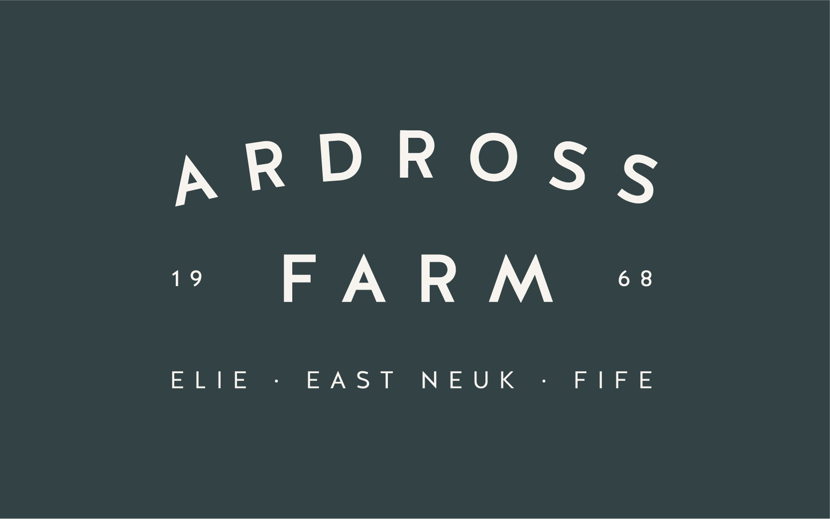
East Neuk Beef - grass-fed & dry aged
All the beef we sell is from our family farm. We are Pasture for Life certified meaning our beef is 100% grass-fed, dry-aged on the bone and butchered to our specifications. We can butcher any cut, any size. If you don’t see what you want on the price list please just ask.
To order just email info@ardrossfarm.co.uk or call 01333 331400
Home Grown Beef | £/kg | Weight
Steak Burgers or Chilli burgers | 5.50 pack | 4 in pack
Sausage meat | £4.95 pack | 500g
Chipolatas | 5.50 pack | 30 in pack
Steak Sausages | 3.75 pack | 6 in pack
Lorne Sausages | 3.75 pack | 4 in pack
Beef Olives | £15.95 | 4 in pack
Fillet Whole | £69.95 | 1-4.5kg
Sirloin Roast | £46.95 | 1-4.5kg
Rib Roast Bone In or Rolled | £49.95 | 1-4.5kg
Rump Roast | £28.95 | 1-4.5kg
Silverside Roast | £22.95 | 1-4.5kg
Topside Roast | £23.95 | 1-4.5kg
Brisket | £19.95 | 1-4.5kg
Fillet Steak | £69.95 | 100-500g
Sirloin Steak | £46.95 | 100-500g
Rib Eye Steak | £49.95 | 100-500g
Rump Steak | £29.95 | 100-500kg
Minute Steak | £24.95 | 100-500g
Stir Fry Strips | £22.95 | approx. 250g
Braising Steak | £19.95 | 250g or 500g
Stewing Steak | £18.95 | 250g or 500g
Mince | £15.00 | 250g or 500g
Short rib | £14.95 | approx 400g
Liver | £6.95
Kidney | £4.05
Bones | £4.00 | knuckle or marrow
Tongue | £6.83
Boiling Beef | £13.95 | approx 400g
Bone Broth | £2.90 | 365ml
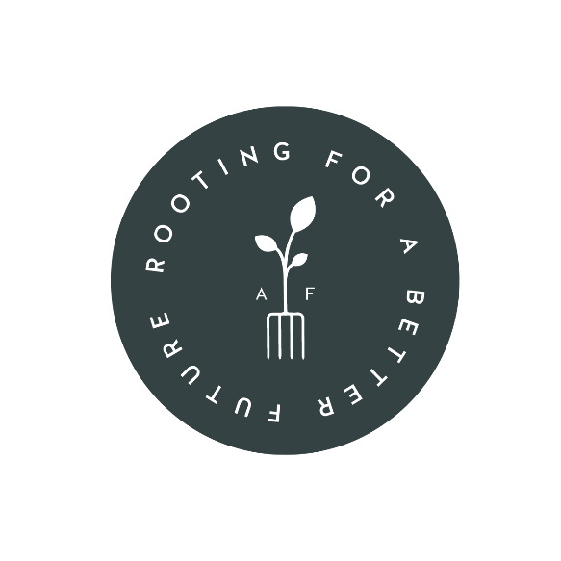

Web: ardrossfarm.co.uk Tel: 01333 331400 Socials: @ArdrossFarm

