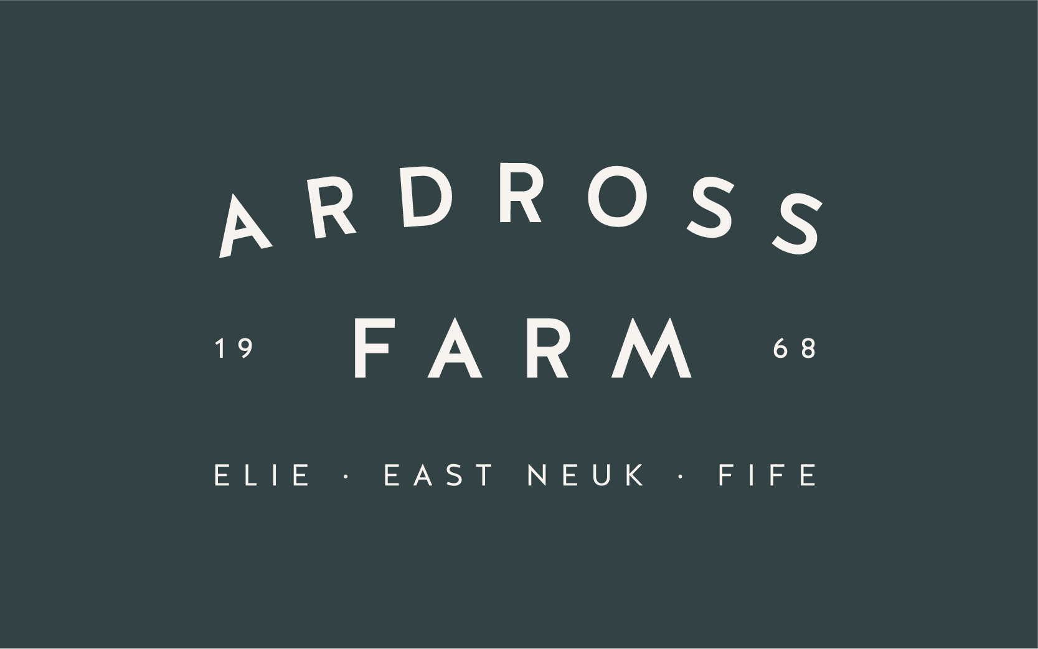

Job Application Form

Position Applied for:
Kitchen Assistant □ (More than one box can be ticked)

1. Personal Details
First Name(s): Surname:

Address:

Post Code:
Email Address:
Telephone (daytime): | Telephone (evening): | Mobile:

2. Secondary Education
Please include secondary qualifications. Continue on a separate sheet if necessary.
School/College Attended | Dates from/to | Qualification and Grades Obtained

3. Further Education
Please include all relevant qualifications. Continue on a separate sheet if necessary.
College/University Attended | Dates from/to | Qualification and Grades Obtained

4. Relevant Courses attended
Name of Course | Dates | Further Details

5. Employment History
Please provide details in chronological order of ALL employment since completing your secondary education. Include all periods not in employment, continue on a separate sheet if necessary.
Details of present or most recent employer
From: | To: | Position/Job Title:
Name and Address:

Main Duties:

Reason for leaving:
Salary:

Dates from/to | Employer’s Name  and Address  and Nature of Business | Job Title  and brief description of main duties and responsibilities | Reason for Leaving
6. Application Question 1
We are keen to understand what attracts you to this post and to Ardross Farm Shop. Please explain why you wish to work for us and how you would contribute to this particular post?

Application Question 2
Whilst working at Ardross Farm, what do you expect your biggest priority will be on a daily basis?

Application Question 3
Experience - What cooking or baking experience have you previously had?

Application Question 4
Flexibility - To work in our farm shop and kitchen, employees need to be willing to be very flexible in terms of the duties they take on. Using examples, please describe your ability to deal with work challenges and changes.

Application Question 5
Future goals and ambitious - Where do you see yourself in five years time?

7. Availability to work
Please let us know how many day’s work you are looking for e.g. Full or Part Time (1,2,3,4 or 5 days a week)
Normal working hours are 8am – 5.30pm for the shop and the kitchen
Please note that we work on a rota basis and every member of the team has to do their share of weekend work – not normally more than every second weekend):

Please give us details of any pre-booked holidays:

8. References
Please provide details of two persons to whom reference may be made prior to interview (one must be your present or most recent employer).
Reference 1 |  | Reference 2
Name: |  | Name:
Job Title: |  | Job Title:
Address: |  | Address:
Telephone No: |  | Telephone No:
E-Mail Address: |  | E-Mail Address:
Can be contacted prior to interview | Yes  No | Can be contacted prior to interview | Yes  No

9. Eligibility to Work
Under the Government Points Based System employers must ensure that any prospective employee is legally entitled to live and work in the UK. All applicants will have to provide documentary evidence, at the interview stage, in the form of either a Passport, Work Permit, Registration Card issued by the Home Office, a document demonstrating that they are a national of a European Economic Area country or Switzerland and Birth Certificate.
Are there any restrictions to your residence in the UK which might affect your right to take up employment in the UK? | Yes | No
If Yes, provide details:
Do you have a current work permit? | Yes | No
If Yes which type of work permit do you have and are there conditions attached?

If No provide details:

10. Recruitment Policy
It is the organisation's policy to employ the best qualified personnel and provide equal opportunity for the advancement of employees including promotion and training and not to discriminate against any person because of race, colour, ethnic origin, national origin, sex, sexual orientation, religion or belief, pregnancy, trans-gender status, marital or civil partnership status, age or disability.
I authorise the organisation to obtain references to support this application once an offer has been made and accepted and release the organisation and referees from any liability caused by giving and receiving information.
Declaration I confirm that the information given on this form is, to the best of my knowledge, true and complete. Any false statement will be sufficient cause for rejection or, if employed, dismissal.

Signed: ________________________________ Date: ___________________
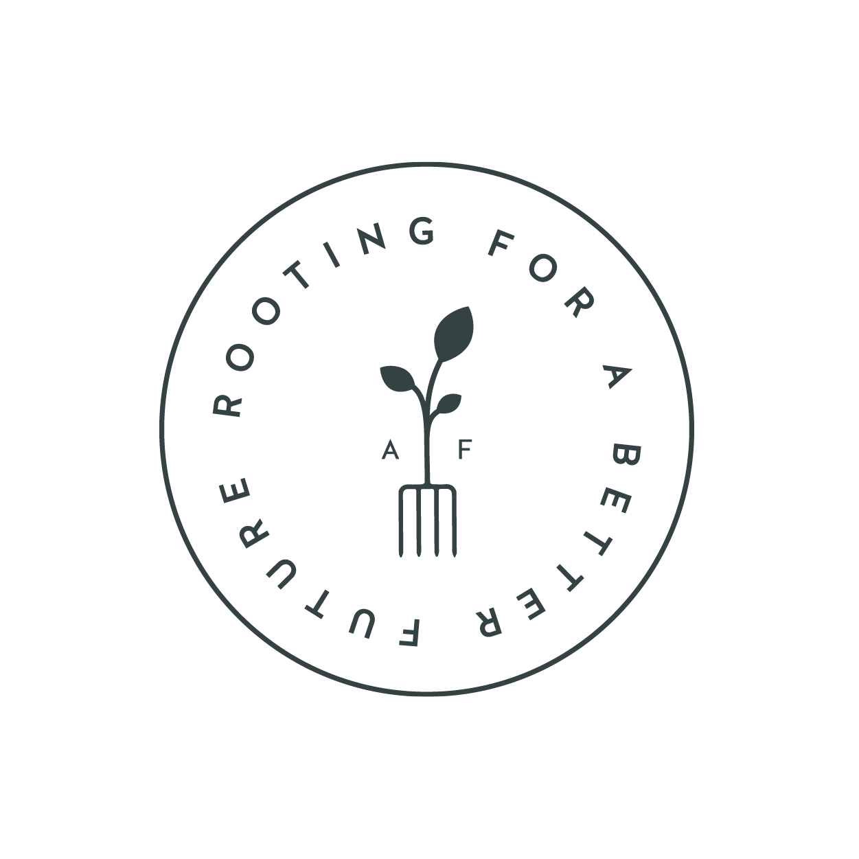

Ardross Farm Shop
Elie
Fife
KY9 1EU
Tel: 01333331400
Email: info@ardrossfarm.co.uk

